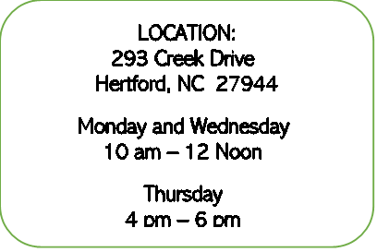


NEW NEIGHBOR INFORMATION APPLICATION
Application Date _____________
Case Number _____________

Name: _______________________________________ Date of Birth: _________________

Address: __________________________________________________________________

Phone Number: _____________________ Perquimans County Resident: Yes ____ No ____
Email address: _______________________

Are You? (Please Circle): Single Married Divorced

Are You? (Please Circle): Employed Unemployed Disabled Retired

Are You? (Please Circle): African American Asian Caucasian Hispanic
Middle Easterner Native American Pacific Islander
Other ____________________________________________

Please list all household members:
Name ___________________________ DOB ___________ Relationship _____________
Name ___________________________ DOB ___________ Relationship _____________
Name ___________________________ DOB ___________ Relationship _____________
Name ___________________________ DOB ___________ Relationship _____________
Name ___________________________ DOB ___________ Relationship _____________
Name ___________________________ DOB ___________ Relationship _____________
If there are more than 6 HH Members, please list on the back of page 1.
Are you receiving Food Stamps?
Yes ____ If yes, you can stop the application process here.
No ____ Must complete the following information on page 2:

THE OPEN DOOR OF PERQUIMANS COUNTY, INC.
NEW CLIENT INFORMATION APPLICATION

NON-FOOD STAMP CLIENTS
INCOME:
Please list sources of income from all household members:
Employment, Disability, Social Security, Retirement, Child Support, All Other Sources of Income

INCOME SOURCE: ____________________ AMOUNT: _________HH MEMBER: _________
Circle Frequency: Weekly Every 2 Weeks Monthly Other (Specify)__________

INCOME SOURCE: ____________________ AMOUNT: _________HH MEMBER: _________
Circle Frequency: Weekly Every 2 Weeks Monthly Other (Specify)__________

INCOME SOURCE: ____________________ AMOUNT: _________HH MEMBER: _________
Circle Frequency: Weekly Every 2 Weeks Monthly Other (Specify)__________

INCOME SOURCE: ____________________ AMOUNT: _________HH MEMBER: _________
Circle Frequency: Weekly Every 2 Weeks Monthly Other (Specify)__________

INCOME SOURCE: ____________________ AMOUNT: _________HH MEMBER: _________
Circle Frequency: Weekly Every 2 Weeks Monthly Other (Specify)__________

OFFICE NOTES:

